Guide to Joining a Teams Meeting for Parents/ Guardians
The following is a brief guide on how to join a meeting on teams for the upcoming parent teacher meeting. We would advise that you make sure you can log into teams well in advance of the meeting (see guide to logging into teams on information page on school website) and that you carry out the meeting using a pc or tablet.
Please only join meetings at your allocated time. Notification will be given in advance of the meeting when the rota is available. It will be accessible via to PTM registration portal.
Late access to a meeting will not be permitted as teachers will be timetabled for other students.

- Log into Teams using a tablet/PC
- At your allocated time click into the teachers 1st Year PTM Team.
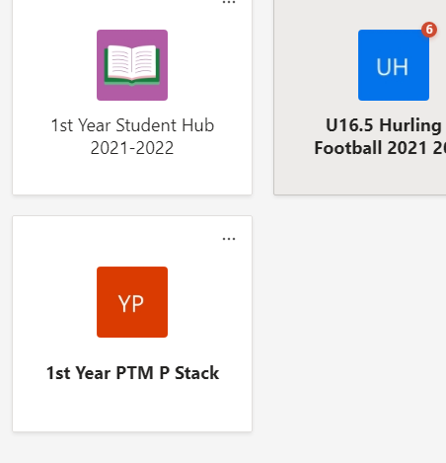
- Ensure that the general channel is selected on the left hand side the Team. The scheduled meeting should appear in the feed in the centre of the screen
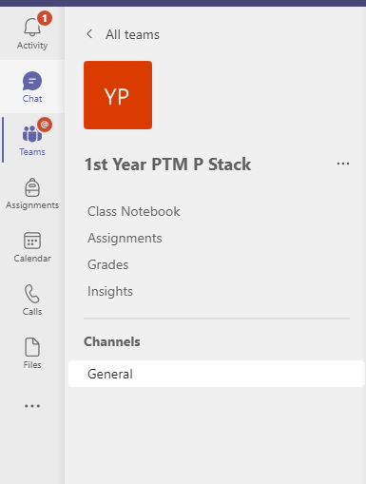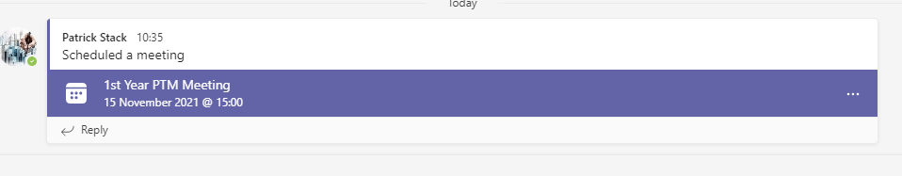

- If the teacher has started the meeting there will be an option to Join.
- You will then be shown the following page before entering the meeting. Please ensure your microphone and camera are turned on and click join now:
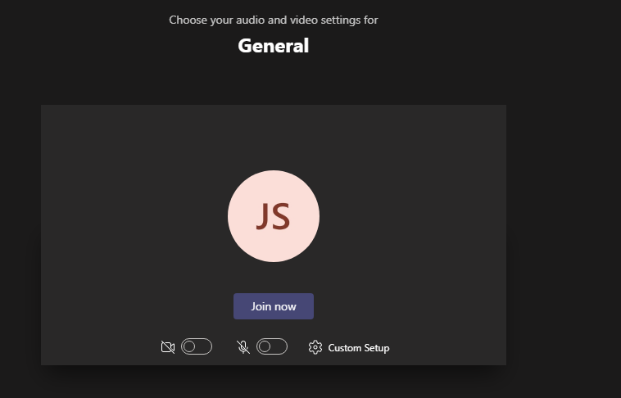
- You will then be showing the screen below until the teacher admits you to the meeting.
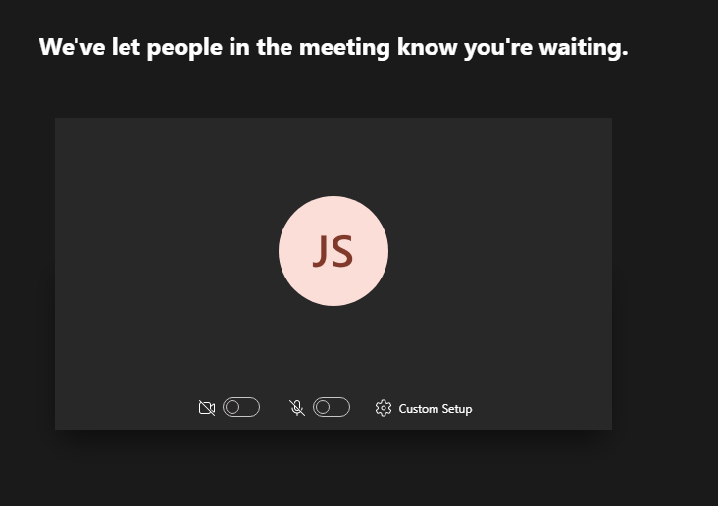
- When you are looking to leave the meeting please click the hang up symbol

