Parent Teacher Meeting Organiser User Manual

Parent Instructions on How to Register and Log into the Parent Teacher Meeting Portal
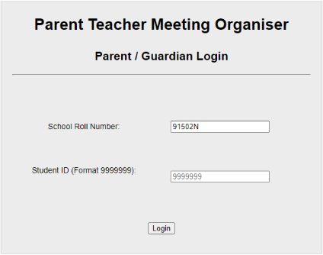
- The PTM registration link can be found on the school website at the following web page: https://johnthebaptistcs.ie/1st-year-parent-teacher-meeting

- Once you click this link the following window will appear. The school roll number should already be filled as 91502N. Enter your child’s VSware ID in the box beside Student ID. If you have lost your student ID please email info@johnthebaptistcs.ie.

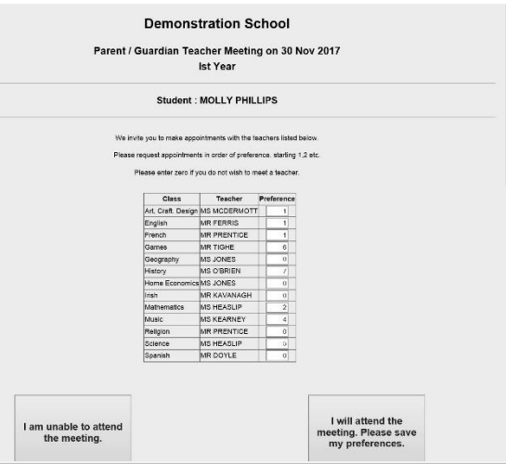
- The following page will invite you to make appointments with your child’s teachers in order of preference. E.g. 1, 2, 3 and so on. You will have the opportunity to meet teachers of; Maths, English, Irish, History, Geography, Science, French and German.
  - An entry of 0 means that you do not wish to meet with that subject teacher.
  - An entry of 1 means your first preference is to have an appointment for that subject teacher.
  - Teachers will only be able to see a maximum of 24 students so therefore it is important that you select your appointments in order of preference.
  - Please number your preferences 1, 2, 3, 4, 5, 6 and 7.
  - At the bottom of the screen there are two buttons for the Parent/ Guardian to indicate whether they:
    - Will not be attending the meeting
    - Will be attending the meeting and want their preferences saved
  - Once you have selected one of the above the system will return you to the parent login screen and a notice to confirm your options will be displayed.

- Accessing Parent/ Guardian Rota
  - You will be able to access your rota in advance of the meeting by logging into the same PTM registration link. Notification will sent by text when the rota is ready to view. It is advised that you print this page or take a screenshot of it.
  - If you want to receive feedback from a teacher who has not been allocated, you can email info@johnthebaptistcs.ie and the year head will contact you at a later stage with a report.
