Home Learning Policy
2019/2020

John the Baptist Community School

Introduction
John the Baptist Community School views home learning as an integral part of the learning process in students. Home learning serves to re-enforce learning done in class and acts as a bridge between the learning of one day and the next. Home learning also helps students to construct knowledge, develop deeper understandings and connections amongst the concepts to which they have been introduced, and provides an opportunity for them to apply the skills they have acquired. It is linked with and integrated into the programme of learning and teaching in JTBCS, thereby forming part of the process of assessment for and as learning.
In setting and reviewing home learning for students, we in John the Baptist understand the purpose of home learning to be:

(A) In relation to class work:
- Home learning reinforces and helps learners to retain information taught in the classroom as well as increasing their general understanding of the content. It reinforces what the student has learnt in class so as to improve their understanding.
- Home learning provides an opportunity for students to practise new skills and concepts and enable students to become more competent in their use.
- Home learning provides continuity between lessons. It may be used to consolidate class work, but also for preparation for the next lesson.
- Home learning provides an opportunity to explore subjects in greater depth than is allowed by class time. It allows for gaining a better understanding of the subject and enhances the educational experience, through the integration of technology enhanced methods i.e. Edmodo etc.
- It provides the student with practice in specific aspects of class work.
- Home learning is an integral part of ongoing learning such as project work.
- Home learning may serve as a means to revise so as to reinforce the learning learned last week/month.
- Home learning provides an opportunity to encourage creativity, critical thinking and extended learning opportunities.

(B) In relation to developing study skills home learning can:
- Encourage the skills needed for students to study effectively on their own and to develop skills such as self-discipline, research and time management, in line with our numeracy strategies.
- Assist the student with examination skills.
- Aid the student in developing language skills and writing skills, in line with our literacy strategies.
- Establish a revision routine.
- Develop good study habits and independent learning.
- Develop a student’s concentration and work ethic.
- Develop an understanding of journal entry, reminders, deadlines, and time management, therefore increasing organisational skills.
- Develop self evaluation.

(C) In relation to monitoring progress home learning can:
- Help teachers to monitor the individual student’s progress.
- Assess a student’s understanding of the learning happening in class.
- Provide a link between home and school.
- Give parents/guardians the opportunity to see the progress of their child.
- Provide regular feedback to the student on their progress in learning.
- Encourages parental responsibility for the student’s progress

(D) In relation to promoting student self-directed learning home learning can:
- Encourage associative learning.
- Establish the habits of study, concentration, research and organisation.
- Provide challenges and stimulus to gifted and talented children.
- Promote self-responsibility for learning.
- Allow students to work at their own pace through differentiated learner outcomes and experiences.
- Allow students an opportunity to engage with feedback in a constructive manner.
- Encourage the development of self-discipline, responsibility and learner autonomy.
- Home learning can be a useful assessment tool, in the form of formative assessment, comment only marking, student self-assessment, or as part of continual or portfolio assessment.
- To develop lifelong skills such as independent learning and research which are transferable to the future.
- To engage and motivate students in homework and home learning as an essential part of the learning process.
Strategies to Support Home Learning
In John the Baptist C.S., we have embedded many active learning methodologies into the learning and teaching that occurs in our classrooms as part of our SSE process. These adaptable strategies in turn serve as a vehicle to achieve deeper thinking and learning in our students both at home and at school to improve their learning outcomes, strengthen student voice and enrich their learner experience.
- Questioning - lower to higher order, remembering to creating (Revised Blooms Taxonomy).
- Reflecting - using the Reflection Arrow students assess their learning on a scale of 1-10, identify how they will improve on this learning and set a time frame for achieving this. It can also be used to track progression and readiness to learn.
- 3-2-1 Activity - Students identify three things they learnt today, two things they are unsure of and identify one question still remaining.
- Create a tweet on the lesson area covered, on a question that is still remaining at the end of a lesson or for the establishment of prior learning.
- Student creation/co-creation of success criteria in order to achieve the learning intentions and develop highly effective practice.
- Note making –mind mapping, graphic organisers, using 5W & 1H template in their journal and reducing information in 5-10 keywords. This reflects the integration of the Magenta Principles and other strategies that have been adapted to our school context teacher, following attendance at strategically targeted professional development opportunities with Mike Hughes and Graham Powell.
- Learning – definitions/spelling/key points: look, say, cover, write & check strategy
- Success criteria outlined consistently, “I must, I should, I could” reminding students of their role as active learner in the classroom
- Teachers provide a series of activities/tasks on a given area in which students have an option of selecting a number of items to complete from the menu. This allows for autonomy and self determination whereby students with different abilities can challenge oneself in their own unique way.
- Students are given a task such as watching a video, researching, reading, reducing and note making on a topic so that the teacher can advance the learning, tackling any queries, while integrating the practice of questions in the following lesson.
- Research various topics using a variety of mediums: Internet, videos, newspapers, books, magazines on various topics.
This list is not exhaustive. All of the above strategies can be integrated with each other to consolidate learning and to create a deeper, richer learning experience for the learner. This in line with our SSE focus in 2019/2020, which aims to consolidate embedded learning strategies, including our SSE strategies.

While such learning strategies can empower and facilitate the identification of gaps in one’s learning and the steps needed to bridge such gaps in content and context of the topic, it is ultimately the responsibility of student to apply consistent and repeated effort and application until they have achieved the expected level of mastery of the topic.

School Self Evaluation and Home Learning
In keeping with our school self evaluation process, we at John the Baptist Community School place particular emphasis on the integration of literacy, numeracy and assessment strategies in the design and selection of home learning tasks and home learning.
- Literacy:
As part of the student’s home learning, the keywords of the chapter may be learned and revised daily. Students are encouraged to use the ‘Look, Say, Cover, Spell, Check’ spelling strategy when learning and completing tasks at home. They are also encouraged to develop their use of comprehension skills and tier two words in their descriptive tasks, using word wheels or Marzona’s template. In the coming academic year, 2019-2020, we will continue to embed spelling strategies, comprehension, and tier two vocabulary and punctuation development.

- Numeracy:
Numeracy is embedded within the learning and teaching in JTBCS and is reflected in the home learning tasks also. Students will be encouraged to adopt numeracy strategies in their planning for and completion of home learning tasks. Such strategies include:
- Calculations where appropriate;
- Graphing;
- Conversion from fraction form to percentages and decimals and vice versa;
- Timing for completion of home learning tasks, timed answers and questions;
- Grading/marks;
- Marking schemes;
- Minimum answer lengths etc.;
- Careful reading of question e.g. when asked for specific number of reasons.

An emphasis will be placed where appropriate on the awareness and use of integers, graphical analysis, conversions from fractions to percentages and decimals and time management in the completion of tasks, in line with the numeracy strategies embedded in our learning and teaching in JTBCS.
When teachers are giving feedback on home learning an emphasis will be placed on numeracy concepts and strategies, e.g. the students use of key phrases in numeracy, use of key symbols of numeracy, students using numerical vocabulary correctly and precisely, communicating the results of a statistical enquiry, their use of comparing by size, mass, etc, sequencing of points, timing.

- Assessment:
In line with SSE, we are placing an emphasis on effective questioning, reflection and self-assessment using success criteria and the development of critical vocabulary in line with our Assessment Policy. Home learning is a continuation of the learning that has occurred in the classroom, and the inclusion of such strategies is encouraged at home also.
Students become more aware of the knowledge and skills that they have developed, through the use of effective questioning strategies and engaging in reflection ‘in’ and ‘on’ their learning at home through completion of appropriate tasks. They are then better able to identify their own strengths and areas for development and devise action plans to facilitate future learning. They gain greater understanding of themselves and how they personally learn and take on more responsibility for their own learning progress through reflection.
Students are encouraged to use effective questioning strategies and reflection strategies in their planning of and completion of home learning tasks, e.g. Students are aware of Blooms taxonomy and are encouraged to develop their higher order thinking skills, tasks should reflect this in their scope and the challenge they pose students of varying abilities. Students will be afforded opportunities and encouraged to analyse, evaluate and create, as well as the lower order skills of recalling, identifying, describing and comparing.
Students are encouraged to use the ‘5 Ws and one H’ strategy, which is included in the student journal, to organise their thoughts, to develop mind maps or plans, and to probe for depth of thinking in their answers. This may also be used to revise a topic or aid the structuring and organisation of student responses.
Students are encouraged to use the reflection arrow to self-assess their own learning at home, to identify their strengths and weaknesses, and to highlight the gap for improvement in their learning. Following on from this the students are encouraged to use success criteria (I must, I should, I could strategy) to improve the depth and quality of their learning and responses. They may also use the tweet posters in conjunction with these strategies, as a home learning assignment to devise questions (using 5 Ws and One H, or Blooms Taxonomy) or to offer feedback on their self-assessment and how they would improve using 3,2,1 or using I must, I should, I could.
Success criteria tell students “what they should know, understand and be able to do, and success criteria help teachers to decide whether their students have in fact achieved the learning intention”. By examining the success criteria during home work, students are able to determine whether they fully understand the content being covered during class and provides students with an opportunity to address these issues in class the next day. Consistent emphasis on student understanding of the meaning of critical vocabulary using the homework tasks to challenge any misconception of the word and to assist successful learning outcomes.
The “5W and 1H” templates are included in the students’ journals, so they can be referenced at home.
Students are encouraged to use these initiatives during every home learning task, in order to increase the depth of their learning. This practice fosters self directed learning capacity within the individual.

Feedback
Feedback is seen as an integral part to home learning in JTBCS. It can take on many forms. While marking of an assignment by the teacher is sometimes necessary, oral feedback, peer and self-assessment are seen as valuable ways of encouraging learner independence. In line with this the teachers may use reflection strategies such as the reflection arrow, tweet boards, success criteria (I must, I should, I could) as a means of encouraging students to think about and assess their own learning and to identify the means to further improve upon their learning and to progress.
Motivating students to do home learning is an ongoing process in JTBCS, and encouragement may be given by written comment or/and verbal communication in order to demonstrate interest on the teacher’s part, particularly in the case of self-study and project work.
In adopting the approach of comment-only marking the teacher gives feedback in three key areas in the student's learning cycle:
- what the student has done right?
- what weaknesses there are in the student's work?
- what the next step/s should be to improve performance or understanding?

This may take the form of two stars and a wish, or using the 3,2,1 strategy. The worth of this kind of feedback in written/oral form is most helpful when the learning intentions and success criteria are clearly understood by the students, as outlined in our assessment policy.

Parental Involvement with Home learning:
Parents/guardians are encouraged to help with home learning by:
- Providing students with a suitable time and place to do their home learning.
- Preventing interruptions and distractions e.g. electronic devices.
- Students should complete written work themselves and parents/guardians should be available and facilitate the student who has difficulty..
- Parents/guardians should check that the student’s home learning is completed each evening.
- The journal should be examined and discussed with the student frequently.
- The student’s journal is an important record for the student’s home learning. It is an invaluable means of communication between parents/guardians and teachers.

Special educational needs:
In setting home learning for students with special needs, teachers are encouraged to balance the right of students to share fully in the work of the class, including home learning tasks, with their individual learning needs. These needs may include consolidation and reinforcement of specific skills. Teachers will collaborate where possible with Learning Support teacher to ensure class tasks are manageable, and individual skill practice can be incorporated without overloading the students.

Supports for students
- Students will be given regular advice on how to organise their home learning efficiently throughout their years in John the Baptist Community School.
- Prior to Induction of first years Parents/guardians/Guardians receive a letter from school which include guidelines on the importance of regular monitoring of the school journal
- As part of the Induction programme first year are given clear guidelines by all subject teachers during the first week of the school year. No home learning is given to students for the first week which allows time to teach home learning study skills. This includes discussion on where to do home learning, how to present it and how to make a home learning plan.
- As a result of a pilot programme 2012/2013, a new study skills programme has been introduced to the second year programme with special attention to mind mapping, note taking, focused reading and time management.
- Guidance is also given at information sessions at the beginning of 5th and 6th year of the Senior Cycle. The subject teachers continuously reinforce this guidance in class. The focus is on maximising each student’s opportunity to realise their academic potential. Guidelines are given on the amount of time that home learning involves at this level. In the Senior Cycle programmes, advice is given by teachers in their particular subject areas. The school’s Guidance Department offers regular advice, direction and support on how to plan home learning and study effectively.
- Home work intervention programme
- Students should carefully record the instructions for their home learning in the journal for each class. When home learning is completed it should be marked as done.

Published guidelines for amount of time spent at home learning (ASTI) are as follows:

- First year approx. 1.5 hours
- Second year approx. 1.5 to 2 hours
- Third year approx. 2 to 3 hours
- Senior cycle (Leaving Cert est.) approx 3 hours

These are guidelines and the amount will vary considerably with the programme that a student is taking. Tutors, year heads and the Guidance Counsellor are available to offer individual advice to students. Students and their Parents/Guardians are encouraged to discuss possible solutions where a problem exists. In the case of students with reasonable accommodation the resource department will provide appropriate advice on how to progress. The school always welcomes the chance to meet with Parents/guardians/Guardians, if not at the parent-teacher meeting, then by appointment at a suitable time. Teachers will, as appropriate, reward very good home learning and significant improvement in home learning. Notes to parents/guardians in the journal may be used for this purpose.

Arrangements for monitoring and evaluating home learning policy:
The effectiveness of this home learning policy needs to be monitored and evaluated. JTBCS will monitor and evaluate the quality of home learning and the contribution it is making to learning will be discussed at subject department meetings. In addition, the home learning policy will be reviewed and updated regularly to assess its effectiveness and to keep up to date with S.S.E. policy and curricular change.

Appendix

- Effective Questioning Templates
  - 5Ws and 1H
  - De Bono’s Thinking Hats
  - Bloom’s Revised Taxonomy
- Reflection Strategies
- Success Criteria Templates
- Literacy Templates
  - Spelling Strategy: Look-Say-Cover-Spell-Check
  - Tier Two Words
  - Marzona Template
  - Punctuation Wheel
- Numeracy Learning Strategies

Appendix 1: Effective Questioning Templates
5Ws and 1H
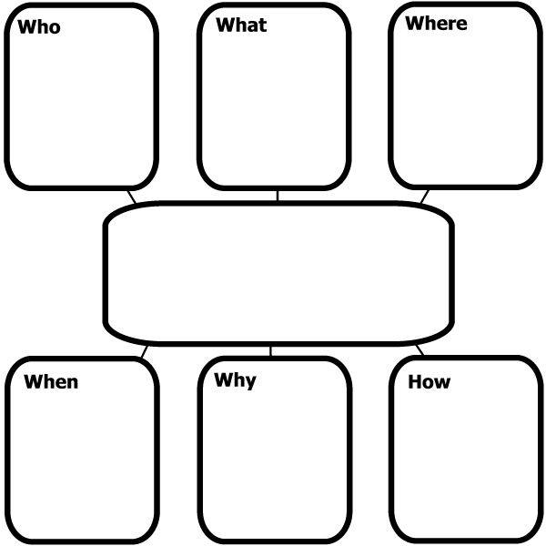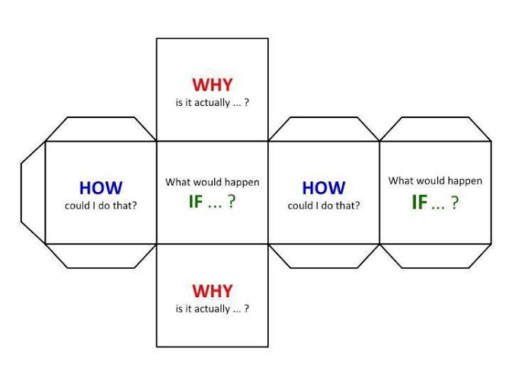
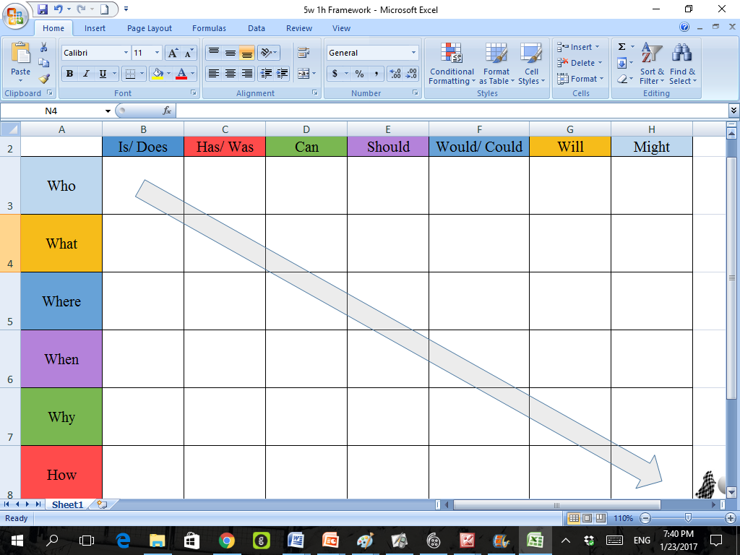

De Bono’s Thinking Hats
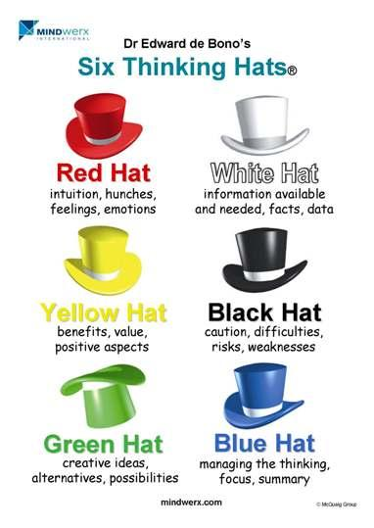

Bloom’s Revised Taxonomy
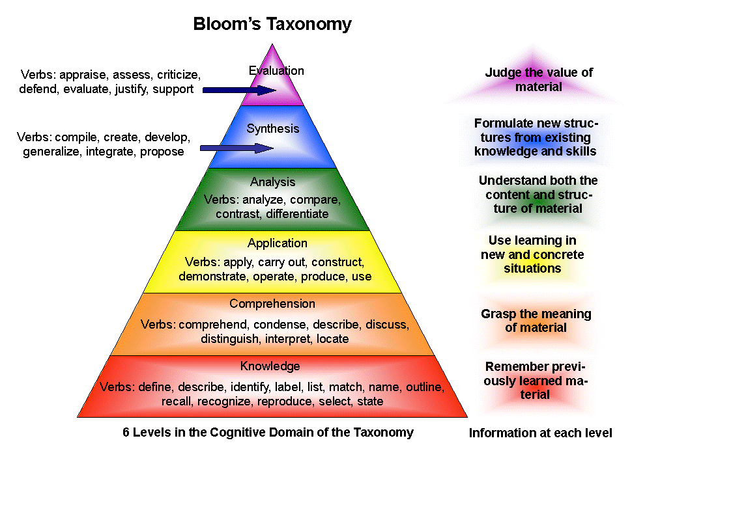
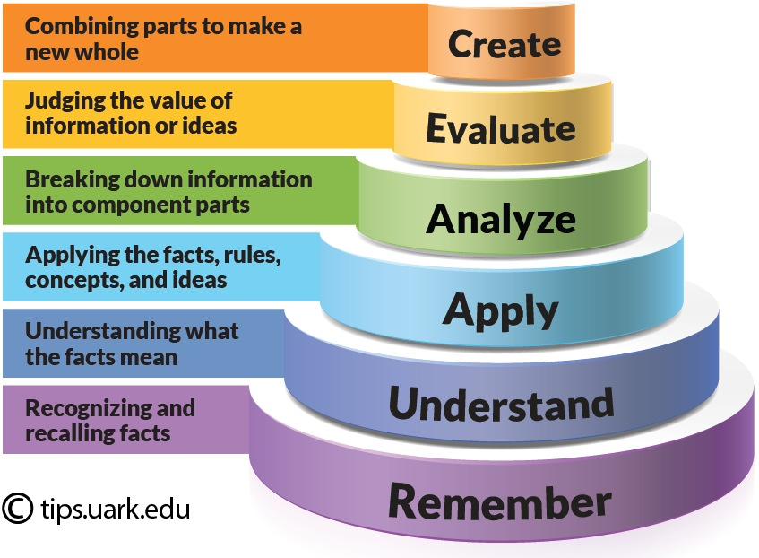
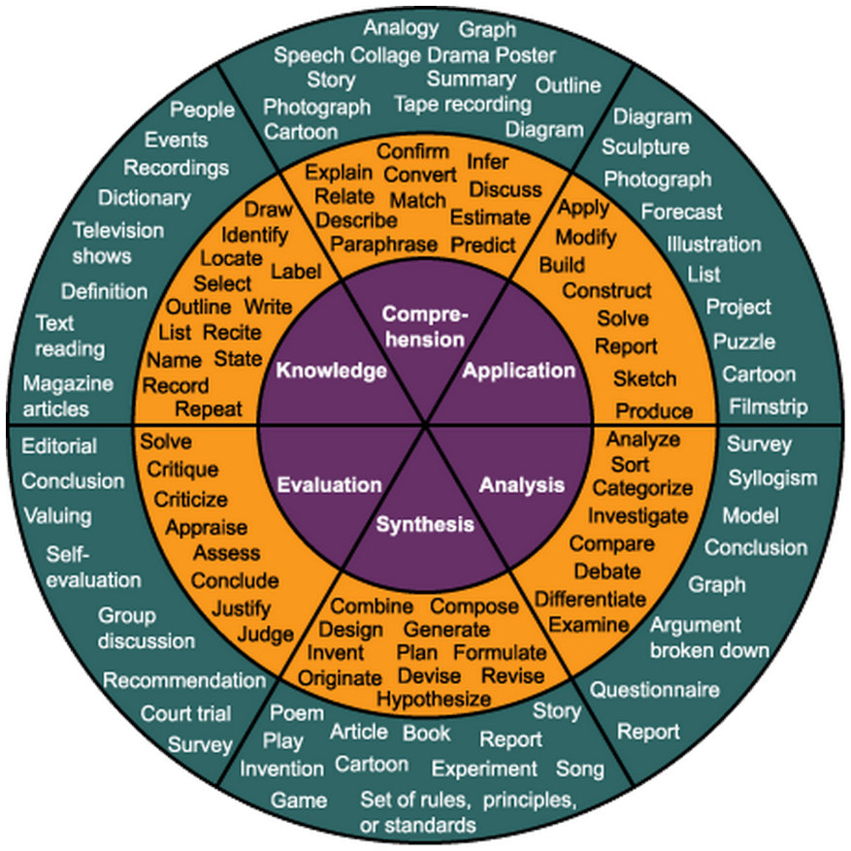
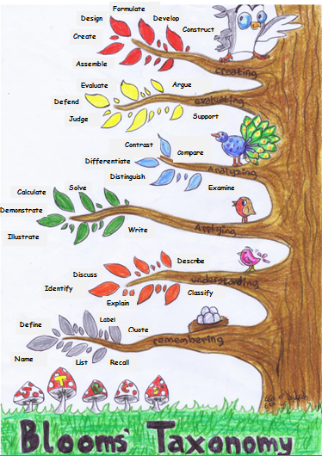

Appendix 2: Reflection Strategies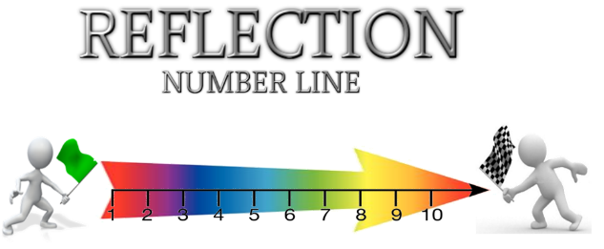

3,2,1 Strategy
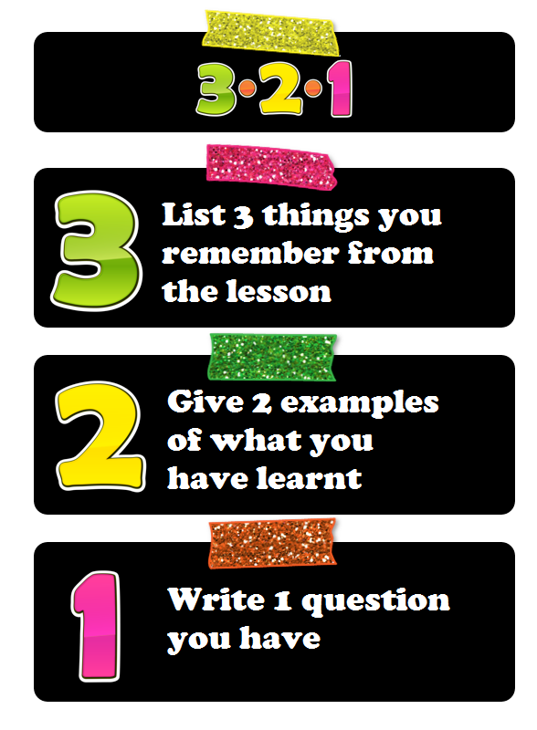

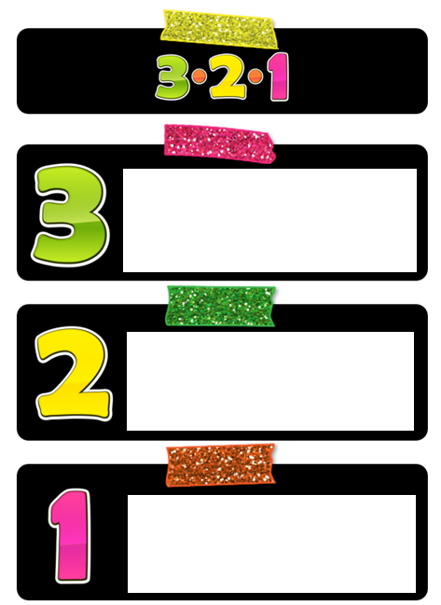

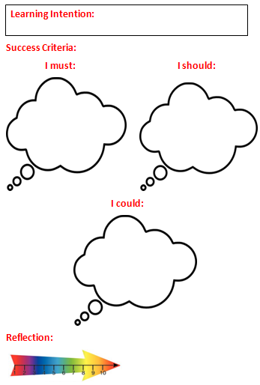
Appendix 3: Success Criteria Templates

I Must | I Should | I Could

Appendix 4: Literacy Templates
Spelling Strategy
Look-Say-Cover-Spell-Check

Tier Two Words
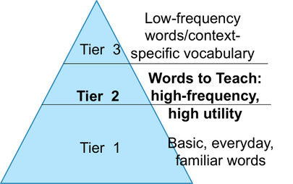
Marzano’s Template
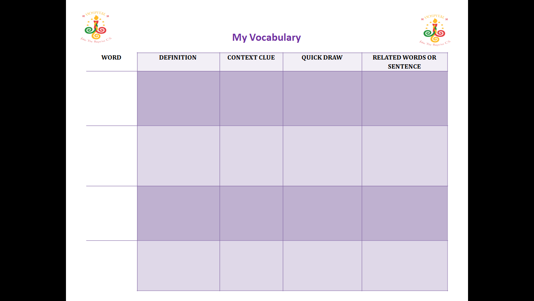

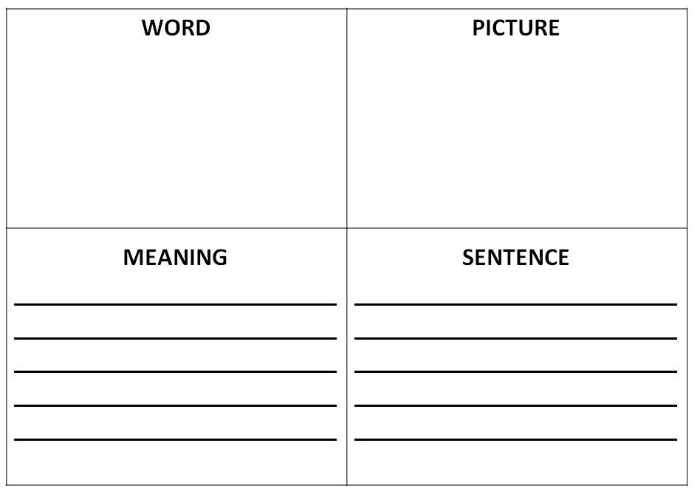

Punctuation Wheel
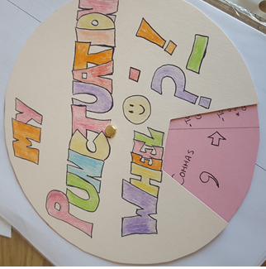

Appendix 5: Numeracy Learning Strategies
Numeracy is embedded within the learning and teaching in and is reflected in the home learning tasks also. Students will be encouraged to adopt numeracy strategies in their planning for and completion of home learning tasks. Such strategies include:
- timing of questions,
- Calculations where appropriate.
- Using statistical analysis to back up information given in answers.
- Graphing
- Conversion from fraction form to percentages and decimals and vice versa.
- Timing for completion of home learning tasks, Timed answers
- Timing for completion of a longer home learning assignment e.g. a project over a week.
- Grading/marks
- Marking schemes
- Minimum answer lengths etc.
- Careful reading of question e.g. when asked for specific number of reasons
An emphasis will be placed where appropriate on the awareness and use of integers, graphical analysis and conversions from fractions to percentages and decimals, in line with our numeracy policy and the numeracy strategies embedded in our learning and teaching in JTBCS. In this current year students will be encouraged to pay particular attention to timing in planning their home learning, completion of tasks, research activities and so on.
When teachers are giving feedback on home learning an emphasis will be placed on numeracy concepts and strategies, e.g. the students use of key phrases in numeracy, use of key symbols of numeracy, students using numerical vocabulary correctly and precisely, communicating the results of a statistical enquiry, their use of comparing by size, mass, etc, sequencing of points, timing.

